Scaffolding Independent Writing
Oral home culture students in the Beginning and Emerging Phases of English-as-an-Additional Language/Dialect

Young Learners

Foundation, Year One, Year Two

5, 6, 7 year olds

Writing Time – allow half an hour each day

Beginning English

Goal - (highlight relevant skills)

By the end of Term/Semester/Year (circle) Foundation/Year One/Year Two (circle) learners will independently write simple sentences using repetitive structure, familiar words and phrases from their oral language, or through following highly structured examples. They will write basic classroom text types when provided with models, using an emerging knowledge of English sentence structure and demonstrating an emerging understanding of the difference between spoken English and written English.
See more detail in the Australian Curriculum

Emerging English

Goal - by the end of Term/Semester/Year (circle) Foundation/Year One/Year Two (circle) learners will write for a range of classroom purposes with varying grammatical accuracy, they still exhibit first language influence.
See more detail in the Australian Curriculum

Ten day cycle
Monday and Tuesday

- Learners draw a picture or writes what he/she can, they ‘speak’ their picture to the teacher
- Teacher scaffolds the student’s language into a full English sentence/utterance
- Teacher repeats sentence/utterance encouraging the writer to join in
- Teacher scribes this sentence/utterance for the student, simultaneously speaking the sentence/utterance
- The student copies the sentence under the teacher’s writing
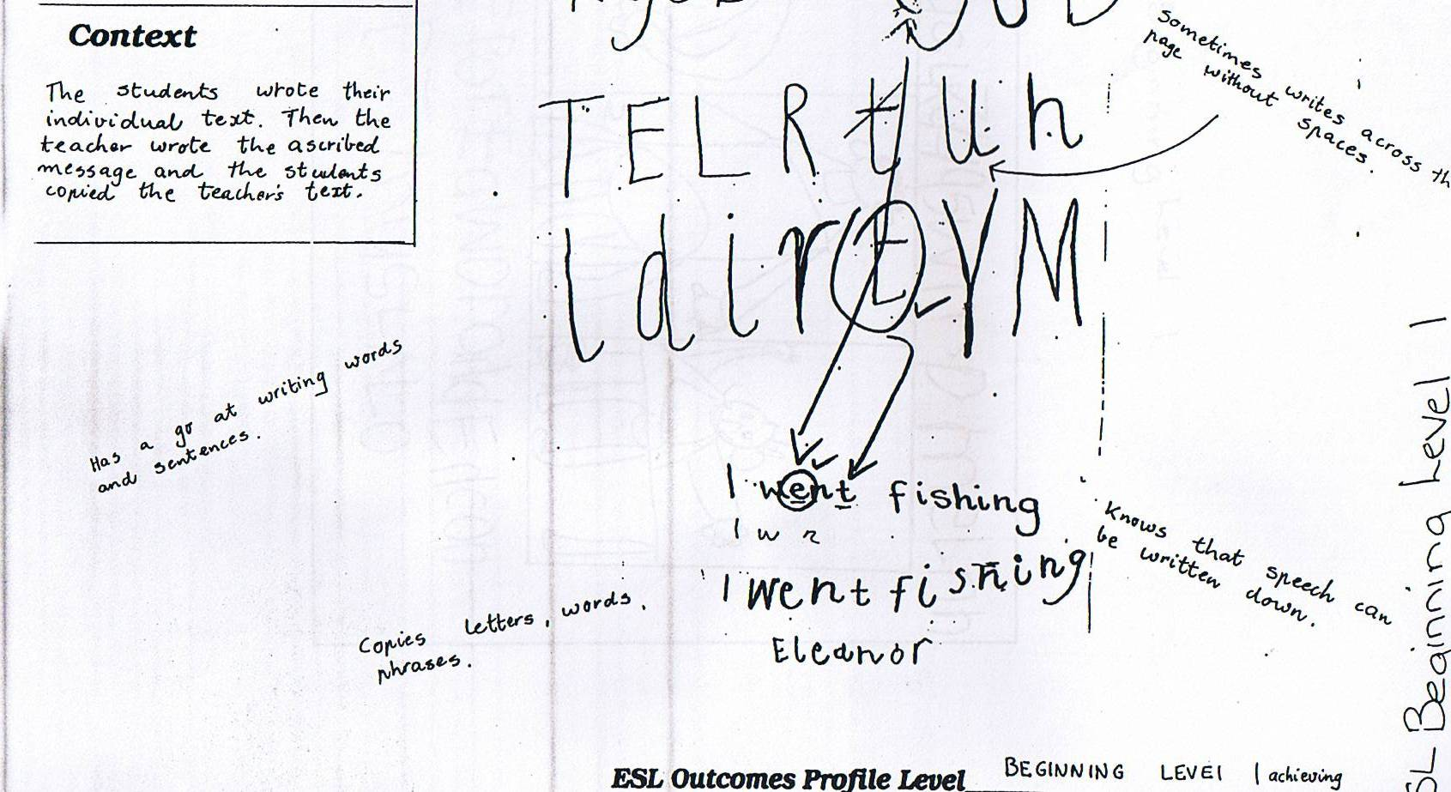 BEGINNING PHASE SAMPLE
- Teacher write each student’s sentence in large print on strips of paper - paste the student’s drawing next to their sentence/utterance
- Teacher leads the whole class in group reading of the sentences/utterances
- Display these in chart form

Wednesday and Thursday
- Teacher leads the whole class in group reading of the sentences/utterances
Teacher models the following steps first
- Give each student her/his sentence from Monday with one word missing.
I ……. fishing

- The student finds the missing word on the chart and writes it in.

Friday and Monday
- Teacher leads the whole class in group reading of the sentences/utterances
Teacher model the following steps first
- Give each student her/his sentence from Monday of the first week with another word missing which is different to the previous missing word
I went ……….
- The student finds the missing word on the chart and writes it in.

Tuesday and Wednesday
- Teacher leads the whole class in group reading of the sentences/utterances. The teacher will be doing less ‘leading’ at this point as learner’s memory and recognition of the sentences grows

Teacher model the following steps first
- Give each student her/his sentence from Monday with yet another different word missing.
…… went fishing.

The student finds the missing word on the chart and writes it in.

Thursday and Friday
- Whole class does group reading of the sentences.
- Give learners a blank piece of paper - they write whatever they can of
her/his sentence for the week.
- Teacher shows each student which letters/words are correct and fills in the incorrect ones for them.
e.g. if the student wrote
I w t f c g

I went fishing

- If learners did not get the sentence correct, they copy under the teacher’s correct version.

- Learners take this personally written sentence home for reading.

The student has had the same sentence for two weeks, practising a different word to write each day. Often we expect that EAL/D learners will write something different each day, but they need time to learn the words and how to write them. This approach gives young learners a sense of success at the single word level, while allowing them to get the feel of writing a sentence.
Make sure that each student is working on a different sentence for the next two week period, so they don’t think that writing is just repeating the same sentence over and over. If a ten day period is too long for a small amount of writing, the cycle at these years of school may take only six or eight days.

Collect the sentences from the whole class and allow them to go home with
each student in turn for home reading.
Have each student have turns at taking the chart with everyone’s sentences home.

Emphasize that the writing must come back to school for the next student to take
home. You can ask and remind learners to bring them back, but don’t worry
if they don’t. Just give the next collection to another student at the end of
another two weeks.

Primary School Learners

Year 4, Year 5, Year 6

Writing Time 40 - 45 mins. each day

Beginning English

Goal - (highlight relevant skills)

By the end of Term/Semester/Year (circle) Year 3, 4, 5, 6 (circle) learners will understand some basic purposes for writing, initiate writing for their own purposes and communicate their ideas and experience simply through writing (more than two simple sentences), drawing or copying. They experiment with common classroom text types with varying grammatical accuracy. First language influence is evident in text organisation and language features.
See more detail in the Australian Curriculum

Emerging English

Goal - (highlight relevant skills)

By the end of Term/Semester/Year (circle) Year 3, 4, 5, 6 (circle) learners will reproduce basic models of most classroom text types, but not at the expected levels of the achievement standards. They write a variety of texts in different curriculum areas with some accuracy in text features, organisation and cohesion.
See more detail in the Australian Curriculum

Ten day cycle
Monday and Tuesday
- Learners draw a picture, and write whatever they can to support the picture
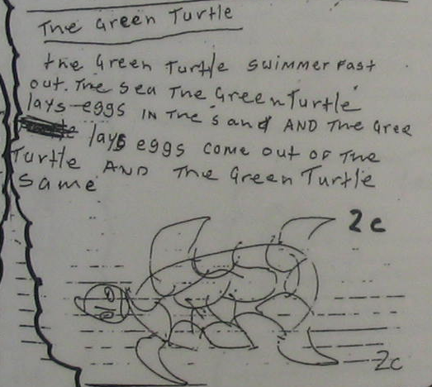
Year 4 (oral home culture) student in a bilingual-with-biliteracy program

- Teacher talks with the student about their writing and when necessary scaffolds the student’s language into a full English sentence/utterance
- Teacher repeats the fully scaffolded sentence/utterance encouraging the writer to join in
- Teacher points out what is correct in the student’s writing then scribes her/his story correctly under the student’s attempt, simultaneously speaking the sentence/utterance, encouraging the learners to ‘speak’ along whilst watching the teacher write

The green turtle swimmer fast out……. The sea The Green Turtle lays eggs

in the sand AND the gree lays eggs come out of the Turtle and the Green

turtle ……..

The green turtle swims fast out in the sea. The green turtle lays eggs in the sand and the eggs come out of the turtle and the green turtle swims away.

- The student copies the teacher’s scribed sentence/s
- Teacher writes each student’s sentences in large print on strips of paper - paste
- the student’s drawing next to it.
- Teacher leads whole class reading of the sentences.
- Display these in chart form

Wednesday and Thursday
- Teacher leads whole class reading of the sentences.
Teacher models the following steps first
- Give each student their piece of writing from Monday/Tuesday with one or two words/phrases missing.
The green turtle ………… out in the sea. The green turtle lays eggs in the sand and the …………………. of the turtle and the green turtle swims away.

- The student finds the missing words on the charts and writes them in.

Friday and Monday
- Teacher leads whole class reading of the sentences.
Teacher models the following steps first
- Give each student their piece of writing with different words missing.
The green turtle swims fast out in the sea. The green …………………….. in the sand and the eggs come out of the turtle and the green …………………….

- Student finds the missing words or remembers them and writes them in.
- Encourage the student to add to this story with her/his own words

Baby turtle.. dig in the sand. …….swimming

- Teacher talks with the student about their additional writing and when necessary scaffolds the student’s language into a full English sentence/utterance
- Teacher repeats the additional fully scaffolded sentence/utterance encouraging the writer to join in
- Teacher points out correct parts of the student’s own writing
- Teacher scribes the additional sentences that learners have attempted, simultaneously speaking the sentence/utterance, encouraging the learners to ‘speak’ along whilst watching the teacher write. Teacher may focus on a grammatical element of English (see underlined words above).

The baby turtles dig themselves out of the sand. They swim away.
- Student copies the correct form under the teacher’s scribing

Tuesday and Wednesday
- Teacher leads the whole class in group reading of the sentences/utterances. The teacher will be doing less ‘leading’ at this point as learner’s memory and recognition of the sentences grows
Teacher model the following steps first
- Give each student their extended piece of writing with different words missing.

The green turtle swims fast out in the sea. The green turtle lays eggs in the sand and the eggs come out …………………………… green turtle swims away.
The baby turtles dig themselves out of the sand. They swim ………..

- The student finds the missing words or remembers them and writes them in.

- Encourage the student to add to this story with her/his own words

fast in the sea. ……… eat ……

Teacher talks with the student about their additional writing and when necessary scaffolds the student’s language into a full English sentence/utterance
- Teacher repeats the additional fully scaffolded sentence/utterance encouraging the writer to join in
- Teacher points out correct parts of the student’s own writing
- Teacher scribes the additional sentences that learners have attempted, simultaneously speaking the sentence/utterance, encouraging the learners to ‘speak’ along whilst watching the teacher write. Teacher may focus on a particular element of English (see underlined words above).

They swim fast in the sea. They eat food.
- Student copies the correct form under the teacher’s scribing if needed

Thursday and Friday
- Whole class does group reading of the sentences.
- Give learners a blank piece of paper - they write whatever they can of
- their sentences for the week.
- Teacher shows each student which letter/words are correct and fills in the incorrect ones for them, simultaneously scaffolding through spoken language
- If learners did not get the sentence correct, they copy under the teacher’s correct version.

- Learners take this personally written sentence home for home reading.

Collect the writing on the large strips of paper from the whole class and
allow them to go home with each student in turn to do home reading.

The student has had the same piece of writing for two weeks, adding more information to it over the two weeks. It is important to move students at this level, beyond writing one familiar sentence/piece. This gives the learner time to learn the words and how to write them. This approach gives young learners a sense of success at the word/phrase level, while allowing them to get the feel of writing more than one sentence/piece of information.
Make sure that each student is working on a different starter sentence for the next two week period, so they don’t think that writing is just repeating the same sentence over and over. If a ten day period is too long for a small amount of writing, the cycle at these years of school may take a little less.

Collect the writing from the whole class and allow them to go home with
each student in turn for home reading.

Emphasize that the writing must come back to school for the next student to take
home. You can ask and remind learners to bring them back, but don’t worry
if they don’t. Just give the next collection to another student at the end of
another two weeks.

Secondary School Learners

Years 7, Year 8, Year 9, Year 10

Writing time - 45 minutes a day.
Older students will have more life experiences as well as more developed cognitive abilities. They will have come across print in a variety of settings even thought they may not have engaged independently in writing skills. They draw upon their first language knowledge as they learn English.

Beginning English

Goal - (highlight relevant skills)

By the end of Term/Semester/Year (circle) Year 7, 8, 9,10 (circle) learners will produce basic classroom and social texts following highly structured examples. They will begin to write for a range of everyday classroom and personal purposes using a bilingual dictionary, bilingual teachers’ assistants or bilingual teachers for support. Their first language influence is evident in the way they organise texts.

Emerging English

Goal - (highlight relevant skills)

By the end of Term/Semester/Year (circle) Year 7, 8, 9, 10 (circle) Learners will write independently for a range of classroom purposes with varying grammatical accuracy. They begin to produce a range of text types from across the curriculum, showing coherence and an awareness of purpose and audience.
- If learners are non-writers, follow the Foundation to Year 2 strategy for the first four- six weeks. Of course students at this level will engage with the content at a higher cognitive level than younger learners. Their ability to engage with learning through English is determined by their English language developmental level, not by their cognitive abilities. Learning through/with home language support/is cognitively and linguistically supportive in learning English.

- For the next four to six weeks, follow the guidelines for the Year Two and Three Program

- For the rest of the year, do the following

Divide the class into four groups
- Group one – students from oral home cultures with no previous learning of literacy literacy
- Group Two - those beginning to understand that letters and shapes make words and sentences that have meaning- some beginning literacy skills
- Group Three - those with basic literacy – a small list of sight words, a few grammatical forms, ability to recognize and write some syllables
- Group Four - those who are literate and are moving into the Developing Phase, and confident to work alone on writing for half an hour.

Ten day cycle
Monday and Tuesday
With the whole class
- Brainstorm topics that students can write about (sourced from what is being taught currently) - so they don’t continue to write the same two sentences about catching wallaby and crab or staying at home.
- Give each student the name of their chosen topic, on a strip of paper
- Have each student spend 20 minutes writing what he/she can on the chosen topic.
- Teacher walks around and works with the learners, pointing out what is correct in the learner’s writing.
- Underline the sections/words which are not correct and ask the student to find those words in the class lists/class dictionary/ on the walls in the language flooded classroom.
- If a student has written only a short safe piece - ask the student to work with one other student to verbally compose another sentence to add to this.
- Have the student then attempt to write this additional sentence.

After 20 minutes - take Group One
- Working on each student’s writing, as a group negotiated text with the rest of the students in this group, write the student’s writing in large print on paper.
- Add to this writing as the group jointly constructs a longer written text for and with that student.
- Aim for two sentences with this group.

Wednesday and Thursday

- Members of group one are given their longer written text to work on with some words/sections of sentences missing.
- Learners have to read/recognize what is missing - find the words in the room or remember them and have a go at putting them in the writing.

- Groups Three and Four continue working on the writing they began as for Monday and Tuesday
- After twenty minutes of going around working with all learners, teacher takes Group Two
- Working on each student’s writing, as a group negotiated text with the rest of the students in this group, write the student’s piece in large print on paper. Add to this writing as the group jointly constructs a longer written text for and with that student.
- Aim for three sentences with this group.

Friday and Monday
- Members of group one are given their longer written text to work on with different words/sections of sentences missing.
- Learners have to read/recognize what is missing - find the word in the room or remember them and have a go at putting them in the writing.

- Members of group two are given their longer written text to work on with some words/sections of sentences missing.
- Learners have to read/recognize what is missing - find the word in the room or remember them and have a go at putting them in the writing.

- Groups Three and Four continue working on the same piece of writing as before
- After twenty minutes of working with students, teacher takes Group Three
- Working on each student’s writing, as a group negotiated text with the rest of the students in this group, write the student’s piece in large print on paper. Add to this writing as the group jointly constructs a longer written text for and with that student.
- Aim for a page of writing containing four or more ideas/pieces of information with this group.

Tuesday and Wednesday
- Members of group one are given their longer written text to work on with different words/sections of sentences missing.
- Learners have to read/recognize what is missing - find the word in the room or remember them and have a go at putting them in the writing.

- Members of group two are given their longer written text to work
on with different words/sections of sentences missing.
- Learners have to read/recognize what is missing - find the word in the room or remember them and have a go at putting them in the writing.

- Members of group three are given their longer written text to work on with some sections of sentences and some sentences missing.
- Learners have to read/recognize what is missing - find or remember the words/sentences and have a go at putting them in the writing.
- Group Four continues working on the same piece of writing as before

- After twenty minutes of working with students, teacher takes Group Four
- Working on each student’s writing, as a group negotiated text with the rest of the students in this group, write the student’s text in large print on paper.
- Add to this writing as the group jointly constructs a longer written text for and with that student.
- Aim for more than a page of writing containing four or more ideas with this group.

Thursday and Friday
- Give each student blank paper to write whatever they can of their written text that has been developing for two weeks.
- Teacher shows each student which words/sentences are correct and fills in the incorrect ones for them simultaneously scaffolding through spoken language
- If learners did not get the sentence correct, they copy under the teacher’s correct version.

- Learners take this personally written work home for home reading.

These learners can also take it in turns to take the jointly constructed texts for home reading from within their group.

Australian Curriculum English Additional Language/Dialect Progression
Australian Curriculum EAL/D Learning Progression

